

CSA0501-DATABASE MANAGEMENT SYSTEMS

LAB EXPERIMENTS DATE: 17/07/2026

EXPERIMENT 21– SELECT with various clause – WHERE, pattern matching

AIM: To implement SPACE, SUBSTR, UPPER, LOWER, TRIM, LENGTH, BIT_LENGTH, CHAR_LENGTH, CONCAT, INSTR, LOCATE, MID and POSITION string functions using MySQL.

PROCEDURE:

Select the pet_management database.

Display the existing records from the pet_details table.

Apply string functions to the pet_name column.

Execute SPACE(), SUBSTR(), UPPER(), LOWER() and TRIM().

Execute LENGTH(), BIT_LENGTH() and CHAR_LENGTH().

Execute CONCAT(), INSTR(), LOCATE(), MID() and POSITION().

Verify the results displayed by each function.

PROGRAM:

1. Display all records:

USE pet_management;

SELECT * FROM pet_details;

OUTPUT:

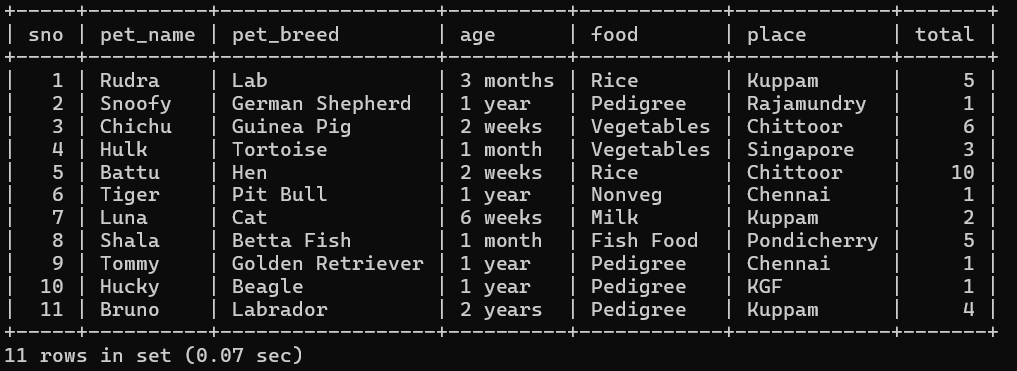

2. SPACE():
SELECT pet_name, CONCAT(pet_name, SPACE(3), pet_breed) AS result
FROM pet_details;

OUTPUT:

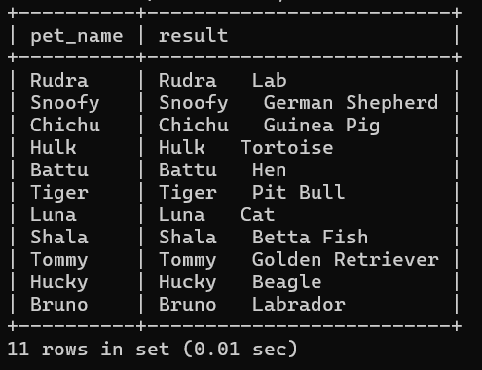

3. SUBSTR():
SELECT pet_name, SUBSTR(pet_name, 1, 3) AS substring
FROM pet_details;

OUTPUT:

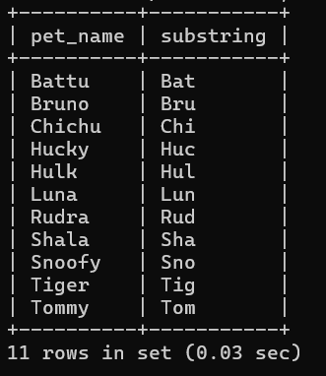

4. UPPER():
SELECT pet_name, UPPER(pet_name) AS uppercase_name
FROM pet_details;

OUTPUT:
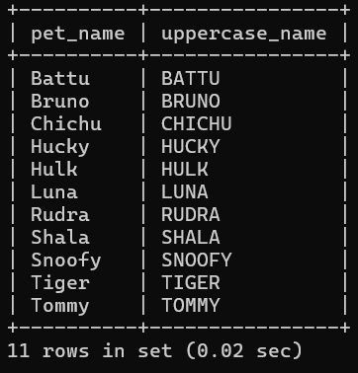

5. LOWER():
SELECT pet_name, LOWER(pet_name) AS lowercase_name
FROM pet_details;

OUTPUT:

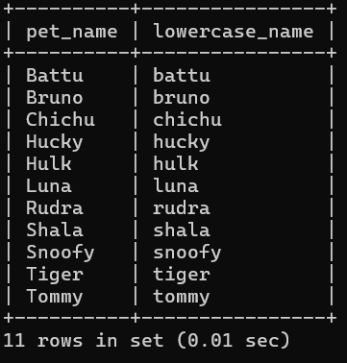

6. TRIM():
SELECT pet_name, TRIM(pet_name) AS trimmed_name
FROM pet_details;

OUTPUT:
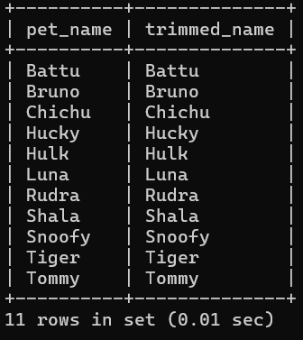

7. LENGTH():
SELECT pet_name, LENGTH(pet_name) AS name_length
FROM pet_details;

OUTPUT:

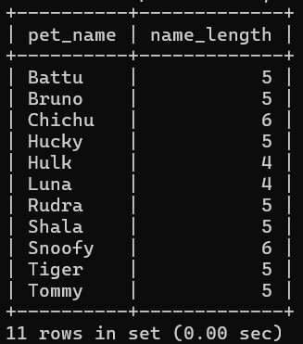

8. BIT_LENGTH():
SELECT pet_name, BIT_LENGTH(pet_name) AS bit_length
FROM pet_details;

OUTPUT:

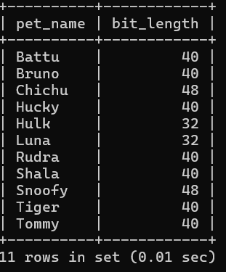

9. CHAR_LENGTH():
SELECT pet_name, CHAR_LENGTH(pet_name) AS character_length
FROM pet_details;

OUTPUT:
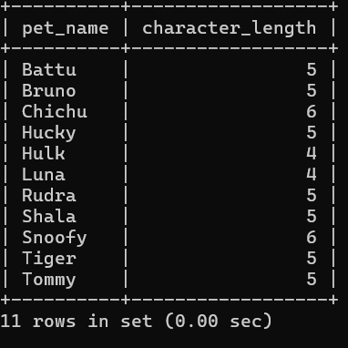

10.CONCAT():
SELECT pet_name, CONCAT(pet_name, ' - ', pet_breed) AS pet_details
FROM pet_details;

OUTPUT:
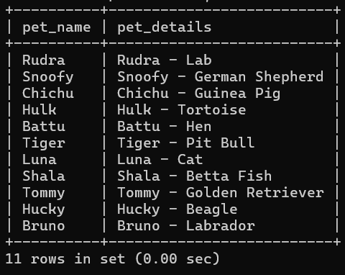

11. INSTR():
SELECT pet_name, INSTR(pet_name, 'a') AS position
FROM pet_details;

OUTPUT:
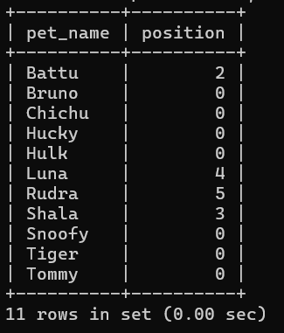

12. LOCATE():
SELECT pet_name, LOCATE('a', pet_name) AS position
FROM pet_details;

OUTPUT:

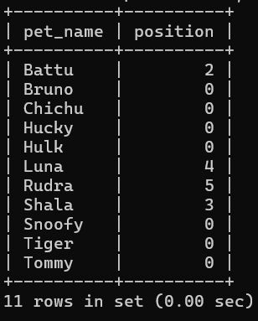

13. MID():
SELECT pet_name, MID(pet_name, 1, 3) AS middle_part
FROM pet_details;

OUTPUT:

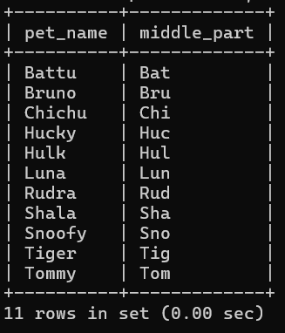
14. POSITION():
SELECT pet_name, POSITION('a' IN pet_name) AS position
FROM pet_details;

OUTPUT:
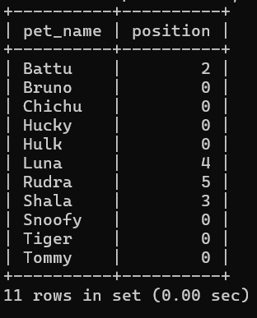

RESULT: The MySQL string functions SPACE, SUBSTR, UPPER, LOWER, TRIM, LENGTH, BIT_LENGTH, CHAR_LENGTH, CONCAT, INSTR, LOCATE, MID and POSITION were executed successfully and the required results were obtained

